**PORTFOLIO MODULE-4**

**S.KUMARI**

**GENDER INTEGRATION**

**Gender integration** (or mainstreaming) is the process of assessing the implications for women and men of any planned action, including legislation, policies or programmes, in all areas and at all levels. ... The ultimate goal is to achieve **gender EQUALITY.**

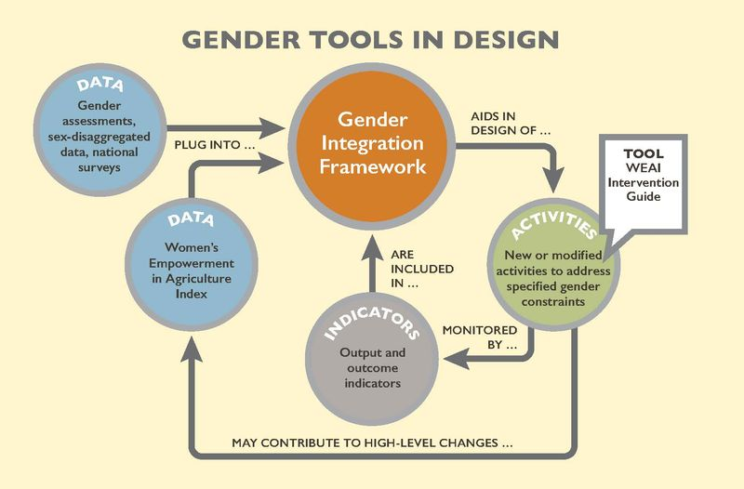

**Gender Integration** refers to strategies applied in program assessment, design, implementation and evaluation to take **gender** norms into account and to compensatefor **gender**-based inequalities. **Gender integration** supports the development and implementation of **gender**-transformative health programs, policies, and services.

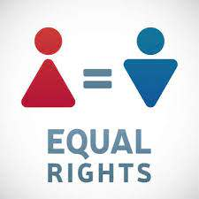

**Gender mainstreaming** is an approach to policy-making that takes into account both women's and men's interests and concerns. The concept of **gender mainstreaming** was first introduced at the 1985 Nairobi World Conference on Women.

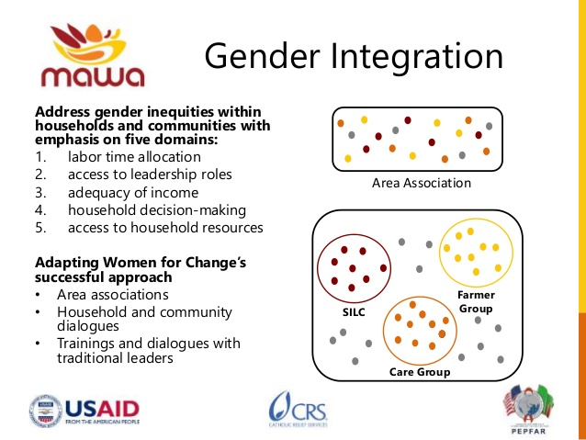



**STRONG WOMEN**

**MAKE HISTORY.**

